**APPENDIX A**

Course code and name: BC

Student ID: CA17093

Name: WONG HUNG CHAN

Section: 02A

Lecturer name: Miss Azlina

Output status (please tick Yes or No):

|  |  |
| --- | --- |
|  |  |
| 100% display correct output: | YES |
|  |  |
| Answer this section if your answer in the above is **NO** | |
| 1. DISC. (%): | YES NO SOME COLUMN ONLY  x |
| 1. SUBTOTAL (RM): | YES NO SOME COLUMN ONLY |
| 1. ITEM QUANTITY: | YES NO |
| 1. PRICE (RM): | YES NO |
| 1. SHIPPING PRICE (RM): | YES NO |
| 1. TOTAL PRICE (RM): | YES NO |
| 1. Banner and footer | YES NO |
|  |  |
|  |  |

Print-screen here your output (before and after Submit button is clicked):

**BEFORE SUBMIT BUTTON IS CLICKED**

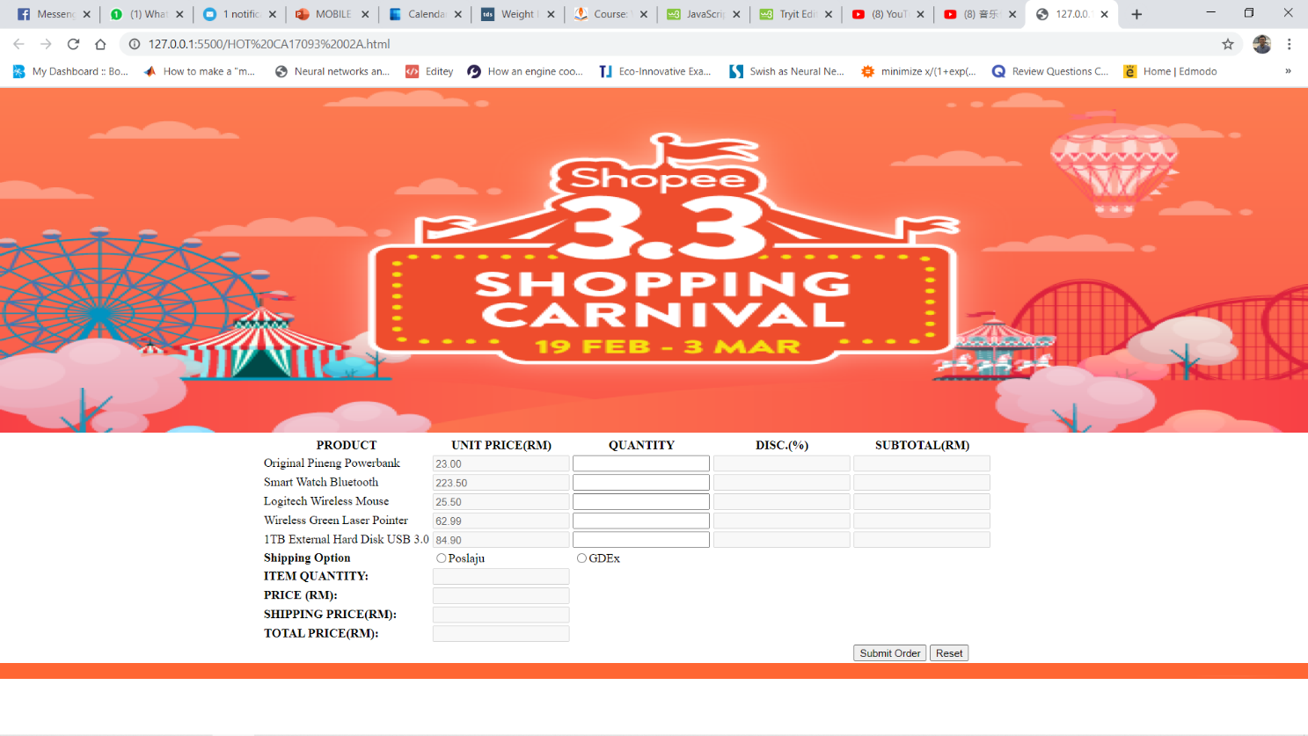

**AFTER SUBMIT BUTTON IS CLICKED (POSLAJU)**

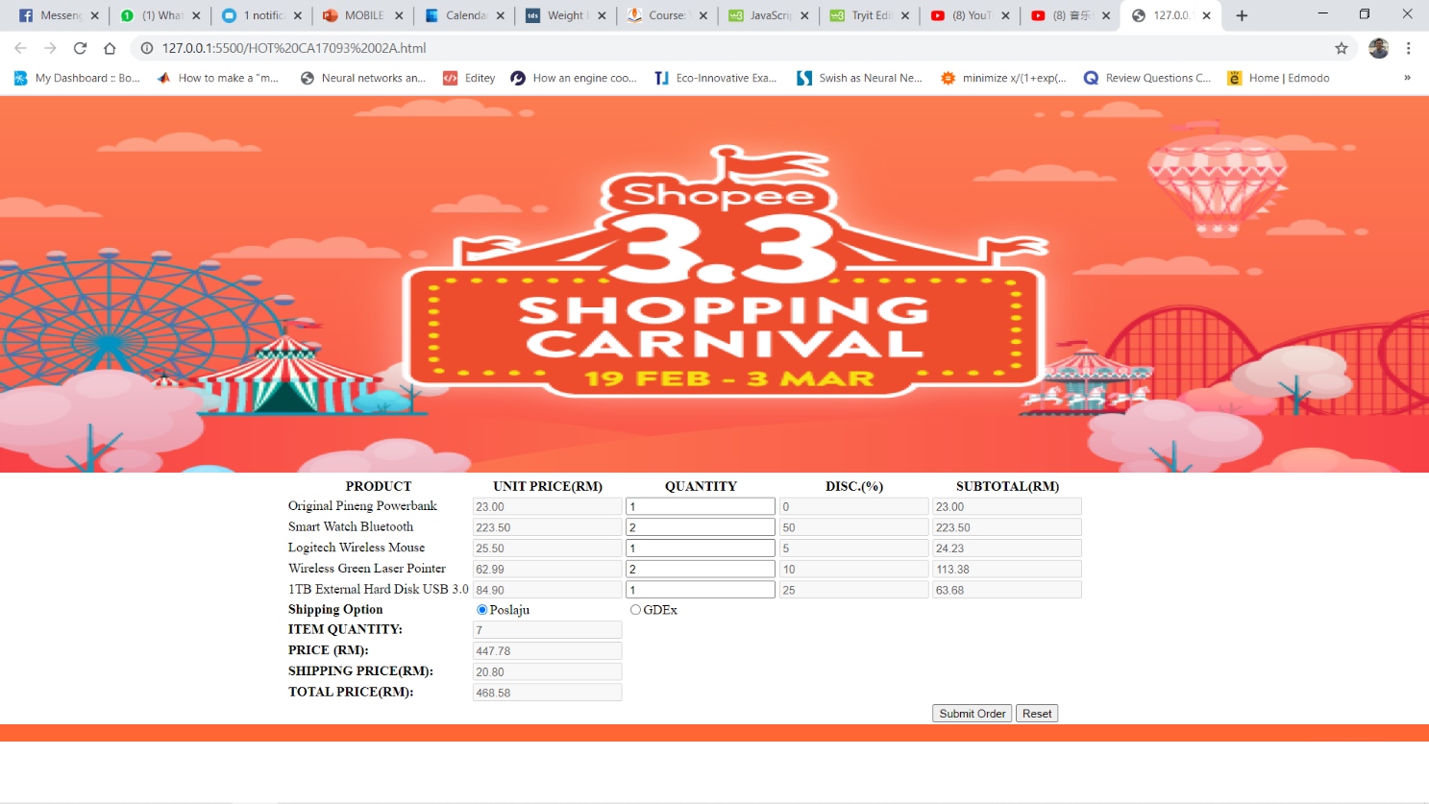

**AFTER SUBMIT BUTTON IS CLICKED (GEDEx)**

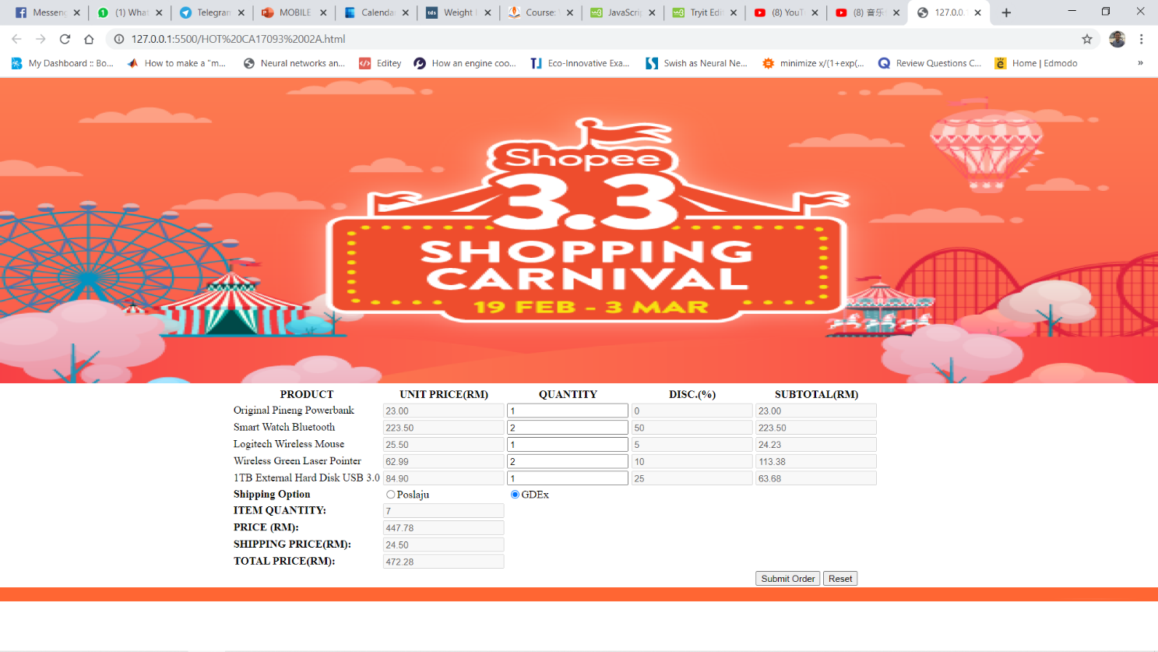

**Html FILE**

<!DOCTYPE html>

<html>

<head>

<meta name="author" content="WONG HUNG CHAN CA17093 02A">

<meta charset="UTF-8">

<link href="hotCa17093.css" rel="stylesheet" type="text/css">

<!--This Section is Internal Javascript-->

<script>

function order(ship){

var powerbankQty = parseInt(document.getElementById("powerbankQty").value);

var watchQty = parseInt(document.getElementById("watchQty").value);

var mouseQty = parseInt(document.getElementById("mouseQty").value);

var laserQty = parseInt(document.getElementById("laserQty").value);

var diskQty = parseInt(document.getElementById("diskQty").value);

var itemQty = powerbankQty + watchQty + mouseQty + laserQty + diskQty;

var powerbankUnit = parseFloat(document.getElementById("powerbankPrice").value);

var watchUnit = parseFloat(document.getElementById("watchPrice").value);

var mouseUnit = parseFloat(document.getElementById("mousePrice").value);

var laserUnit = parseFloat(document.getElementById("laserPrice").value);

var diskUnit = parseFloat(document.getElementById("diskPrice").value);

var powerbankDisc = discount(powerbankUnit);

var watchDisc = discount(watchUnit);

var mouseDisc = discount(mouseUnit);

var laserDisc = discount(laserUnit);

var diskDisc = discount(diskUnit);

var powerbankSubtotal = powerbankQty * powerbankUnit.toFixed(2) - ((powerbankQty * powerbankUnit.toFixed(2)) * (powerbankDisc / 100));

var mouseSubtotal = mouseQty * mouseUnit.toFixed(2) - ((mouseQty * mouseUnit.toFixed(2)) * (mouseDisc / 100));

var watchSubtotal = watchQty * watchUnit.toFixed(2) - ((watchQty * watchUnit.toFixed(2)) * (watchDisc / 100));

var laserSubtotal = laserQty * laserUnit.toFixed(2) - ((laserQty * laserUnit.toFixed(2)) * (laserDisc / 100));

var diskSubtotal = diskQty * diskUnit.toFixed(2) - ((diskQty * diskUnit.toFixed(2)) * (diskDisc / 100));

var totalBeforeShip = powerbankSubtotal + mouseSubtotal + watchSubtotal + laserSubtotal + diskSubtotal;

document.getElementById("powerbankDisc").value = powerbankDisc;

document.getElementById("watchDisc").value = watchDisc;

document.getElementById("mouseDisc").value = mouseDisc;

document.getElementById("laserDisc").value = laserDisc;

document.getElementById("diskDisc").value = diskDisc;

document.getElementById("powerbankSub").value = powerbankSubtotal.toFixed(2);

document.getElementById("watchSub").value = watchSubtotal.toFixed(2);

document.getElementById("mouseSub").value = mouseSubtotal.toFixed(2);

document.getElementById("laserSub").value = laserSubtotal.toFixed(2);

document.getElementById("diskSub").value = diskSubtotal.toFixed(2);

document.getElementById("totalQty").value = itemQty;

document.getElementById("beforeShippingPrice").value = totalBeforeShip.toFixed(2);

var shippingValue = shipment(ship,totalBeforeShip);

var totalAfter = (totalBeforeShip + shippingValue).toFixed(2)

document.getElementById("shippingPrice").value = shippingValue.toFixed(2);

document.getElementById("afterShippingPrice").value = totalAfter;

}

function shipment(ship, price){

if(ship == "Poslaju"){

if(price > 100){

return 20.80;

}

else if(price > 50){

return 12.80;

}

else if(price > 20){

return 11.80;

}

else{

return 7.20;

}

}

else{

if(price > 100){

return 24.50;

}

else if(price > 50){

return 15.50;

}

else if(price > 20){

return 13.00;

}

else{

return 11.50;

}

}

}

function discount(unitPrice){

if(unitPrice > 100){

return 50;

}

else if(unitPrice >=75){

return 25;

}

else if(unitPrice >= 50){

return 10;

}

else if(unitPrice >= 25){

return 5;

}

else{

return 0;

}

}

</script>

</head>

<body>

<header>

<img src="shoppee.png" alt="shoppee picture">

</header>

<div class="container">

<form onsubmit="return false">

<table>

<tr>

<th>PRODUCT</th>

<th>UNIT PRICE(RM)</th>

<th>QUANTITY</th>

<th>DISC.(%)</th>

<th>SUBTOTAL(RM)</th>

</tr>

<tr>

<td>Original Pineng Powerbank</td>

<td><input type="text" value="23.00" id="powerbankPrice" disabled></td>

<td><input type="text" id="powerbankQty" required></td>

<td><input type="text" id="powerbankDisc" disabled></td>

<td><input type="text" id="powerbankSub" disabled></td>

</tr>

<tr>

<td>Smart Watch Bluetooth</td>

<td><input type="text" value="223.50" id="watchPrice" disabled></td>

<td><input type="text" id="watchQty" required></td>

<td><input type="text" id="watchDisc" disabled></td>

<td><input type="text" id="watchSub" disabled></td>

</tr>

<tr>

<td>Logitech Wireless Mouse</td>

<td><input type="text" value="25.50" id="mousePrice" disabled></td>

<td><input type="text" id="mouseQty" required></td>

<td><input type="text" id="mouseDisc" disabled></td>

<td><input type="text" id="mouseSub" disabled></td>

</tr>

<tr>

<td>Wireless Green Laser Pointer</td>

<td><input type="text" value="62.99" id="laserPrice" disabled></td>

<td><input type="text" id="laserQty" required></td>

<td><input type="text" id="laserDisc" disabled></td>

<td><input type="text" id="laserSub" disabled></td>

</tr>

<tr>

<td>1TB External Hard Disk USB 3.0</td>

<td><input type="text" value="84.90" id="diskPrice" disabled></td>

<td><input type="text" id="diskQty" required></td>

<td><input type="text" id="diskDisc" disabled></td>

<td><input type="text" id="diskSub" disabled></td>

</tr>

<tr>

<td><strong>Shipping Option</strong></td>

<td><input type="radio" name="shipping" id="shipping" value="Poslaju">Poslaju</td>

<td><input type="radio" name="shipping" id="shipping" value="GDEx" >GDEx</td>

</tr>

<tr>

<td><strong>ITEM QUANTITY:</strong></td>

<td><input type="text" id="totalQty" disabled></td>

</tr>

<tr>

<td><strong>PRICE (RM):</strong></td>

<td><input type="text" id="beforeShippingPrice" disabled></td>

</tr>

<tr>

<td><strong>SHIPPING PRICE(RM):</strong></td>

<td><input type="text" id="shippingPrice" disabled></td>

</tr>

<tr>

<td><strong>TOTAL PRICE(RM):</strong></td>

<td><input type="text" id="afterShippingPrice" disabled></td>

</tr>

<tr>

<td></td>

<td></td>

<td></td>

<td></td>

<td><button type="submit" onclick="order(shipping.value)">Submit Order</button> <button type="reset">Reset</button></td>

</tr>

</table>

</form>

</div>

<footer><img src="footer.png" alt="footer"></footer>

</body>

</html>

**CSS FILE**

html{

box-sizing: border-box;

}

*,*::before,*::after{

box-sizing: inherit;

}

body{

margin:0;

padding:0;

}

.container{

margin:0 auto;

width: 60%;

}

header img{

width:100%;

height:450px;

}

footer img{

height:20px;

width:100%;

}